Contacts: General Manager: Aled Humphreys
Conference and Events Manager: Matthew Luscombe
Hotel Operations Manager: Kristel Langley

Location: The hotel is ideally situated outside Chester, with easy links to both the A55 and M56 and is approximately 4 miles from Chester and 23 miles from Liverpool

Style: Rowton Hall Hotel and Spa offers you a country hotel with a difference delivering first class service. All our bedrooms offer spacious accommodation with seriously comfy beds, fluffy towels and ‘want to use’ toiletries as well as all the extras you would expect from a 4 Star hotel. Dining at the Hotel is a must, our Restaurant offers modern cuisine making the most of local produce and produce from our very own kitchen garden while our wine list takes you on a worldwide tour. The hotels extensive grounds are perfect for your team building needs.

Nearest: Major Town: Chester
Motorway: A55 & M56
Main Rail Station: Chester
Airport: Liverpool & Manchester

Bedrooms: 39 bedrooms comprising:

Apartments
Master Suites
Superior
Premier
Classic Double / Twin

All With: Complimentary Wireless Broadband Connection
Refreshment Tray with Tea & Coffee making facilities
Desk
Telephone
Iron and Ironing Board
Hairdryer

Dining: Langdale Restaurant
Cavalier Bar Lounge and Terrace

Choose the best room for your event

The Ballroom
This beautiful room provides an impressive backdrop to any meeting or event accommodating up to 150 guests theatre style. Decorated in neutral tones, The Ballroom is located on the ground floor and can be used in conjunction with the Conservatory, ideal breakout space for refreshments. This room is well suited for large board meetings, presentations and exhibitions.

Inglenook
An elegant high-ceilinged room with an impressive oak inglenook fireplace. This room conveniently interconnects with the lounge, this room is perfect for training, meetings and private dining.

Adams Lounge
This elegant high-ceilinged room has an abundance of natural daylight and is decorated in neutral tones. This room is well suited is perfect for training, meetings and private dining.

The Boardroom
The Boardroom located on the first-floor benefits from neutral tones and natural daylight, The Boardroom is well suited for a small meeting or as a break-out room.

The Grounds
With 8 acres of garden and grounds, we have a number of outside areas perfect for team building events, marquees or quiet areas perfect for those informal alfresco meetings.

Choose the best package for your event

Classic Day and Residential Packages

Day Delegate Rate - £45.00 per person
- Unlimited Servings of Tea and Coffee
- Pastries on arrival (upgrade to bacon rolls for an extra £2.75)
- Mid-Morning Biscuits
- Cake served in the afternoon
- Lunch – 2 course restaurant lunch, hot and cold buffet
or a working buffet lunch
- Main meeting room hire
- Still and Sparkling Mineral Water
- LCD Projector and Screen
- Flipchart and Pens
- Delegate Stationary

Classic 24hr Delegate Rate - £165.00 per person
- Unlimited Servings of Tea and Coffee
- Pastries on arrival (upgrade to bacon rolls for an extra £2.75)
- Mid-Morning Biscuits
- Cake served in the afternoon
- Lunch – 2 course restaurant lunch, hot and cold buffet
or a working buffet lunch
- Main meeting room hire
- Still and Sparkling Mineral Water
- LCD Projector and Screen
- Flipchart and Pens
- Delegate Stationary
- 3 course restaurant dinner
- Overnight accommodation in a Classic Room
- Full country house breakfast

HomeSpace - £19.00 per delegate
When homeworking is just not an option, let us provide everything you need for a safe and productive working environment.

Work on your own or meeting with clients or colleagues, our package is scalable with many options available to fit in with your needs, your package includes:
- Wi-fi access
- Free printing
- Lunch Box
- Unlimited tea and coffee
- Unlimited Mineral Water
- Relax at the end of the day with an hour in our club and spa
Signature Day and Residential Packages

Day Delegate Rate - £60.00 per person
- Unlimited Servings of Tea and Coffee
- Bacon Rolls on arrival or Healthy Breakfast Options
- Mid-Morning Biscuits
- Afternoon break to be a choice of cake and a fruit platter
or freshly baked scones with jam and cream
- Lunch – 2 course restaurant lunch, hot and cold buffet
or a working buffet lunch
- Jugs of Fruit Juice and bottled water with Lunch
- Bottles of soft drinks in the main meeting room
- Main meeting room hire
- Still and Sparkling Mineral Water
- LCD Projector and Screen
- Flipchart and Pens
- Delegate Stationary

Signature 24hr Delegate Rate - £185.00 per person
- Unlimited Servings of Tea and Coffee
- Bacon Rolls on arrival or Healthy Breakfast Options
- Mid-Morning Biscuits
- Afternoon break to be a choice of cake and a fruit platter
or freshly baked scones with jam and cream
- Lunch – 2 course restaurant lunch, hot and cold buffet
or a working buffet lunch
- Jugs of Fruit Juice and bottled water with Lunch
- Bottles of soft drinks in the main meeting room
- Main meeting room hire
- Still and Sparkling Mineral Water
- LCD Projector and Screen
- Flipchart and Pens
- Delegate Stationary
- 3 course restaurant dinner or Terrace BBQ (Weather permitting)
- Overnight accommodation in a Classic Room
- Full country house breakfast
- Choice of 2 items from the list below
  - Pre-dinner canapés
  - Pre-dinner glass of Prosecco
  - 2 Glasses of wine with dinner
  - Extra cheese platter with dinner

Room Hire Costs

Venue | Full Day | Half Day | Evening Only from 6pm
Ballroom | £1,000 | £650.00 | £450.00
Adams Lounge | £550.00 | £300.00 | £250.00
Inglenook | £650.00 | £400.00 | £300.00
Boardroom | £450.00 | £200.00 | £150.00

All room hire prices include mineral water, delegate stationary and VAT at the current rate

Room Capacities

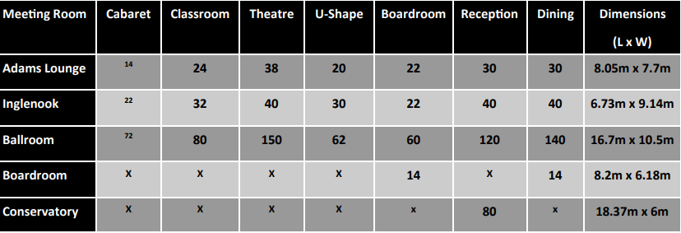

Outdoor Activities………

Our superb grounds and gardens provide the perfect backdrop for a huge range of activities.

Working together with leading event organisers, we can prepare activities to suit your requirements.

Our grounds provide endless opportunities from the more physical activity to the more challenging.

Favorites Include:

- Archery
- Clay pigeon shooting
- Falconry
- Human Table Football
- Cocktail making
- Murder Mystery
- Wine and Champagne Tastings

Nearby Facilities Include:

- Horse Riding
- Go Karting
- Paint Balling
- Rope Works
- Quad Biking

